WEEK 3 ASSIGNMENT
PART A:
1. Swapping of Two Numbers
Write a C program to swap two numbers using a temporary variable.
o Input: Two integers.
o Output: The values after swapping.
Example:
Input: a = 10, b = 20
Output: a = 20, b = 10
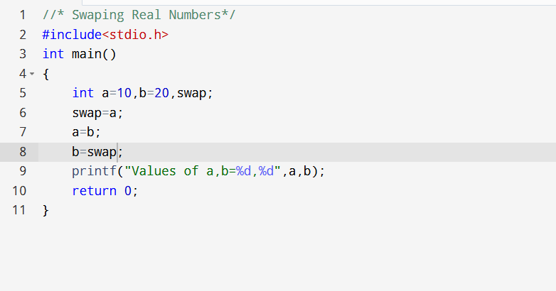
2.Find Sum, Difference, Product, Quotient, and Remainder
Write a C program to input two integers and compute:
o Sum
o Difference
o Product
o Quotient
o Remainder
Example:
Input: a = 15, b = 6
Output: Sum = 21, Difference = 9, Product = 90, Quotient = 2,
Remainder = 3

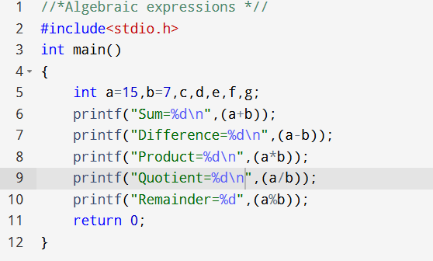
3. Calculate Body Mass Index (BMI)
Write a C program to calculate the BMI of a person.
Formula:
BMI=weight (kg) / (height (m)) 2
Input: Weight in kilograms, Height in meters.
Output: BMI value and category (Underweight, Normal, Overweight, Obese).
Example:
Input: Weight = 70, Height = 1.75
Output: BMI = 22.86 → Normal
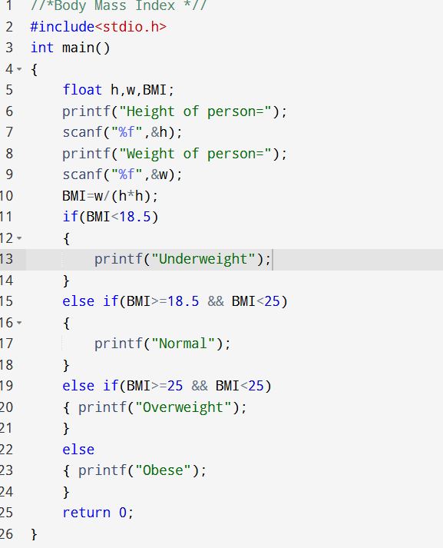
PART B:
a)
printf(“Enter a number: “);
scanf(“%d”,number);

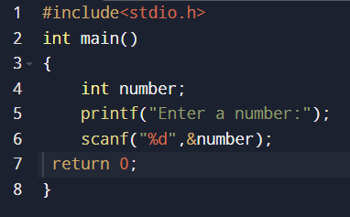
b)
printf(“Value of x is: %d”, x, y);

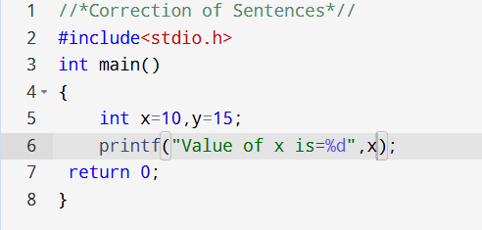

c)
scanf(“%f”, &a, &b);
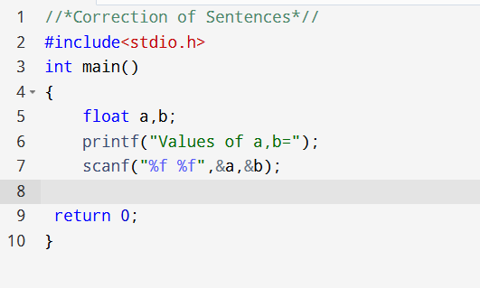

d)
printf(“Sum of %d and %d is %d”, a, b);
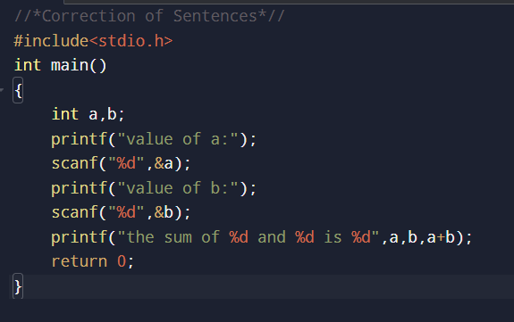
e)
scanf(“%d %d”, a, b);
printf(“The average is %f”, (a+b)/2);
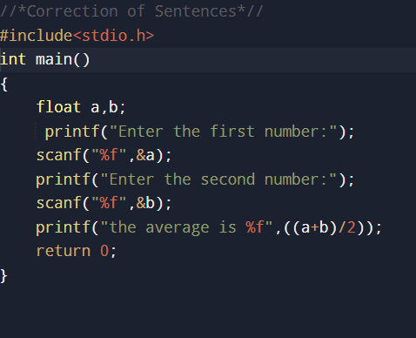

f)
scanf(“%C”, &str);
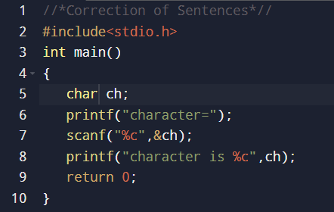

g)
printf(“The value is: %d”, &x);
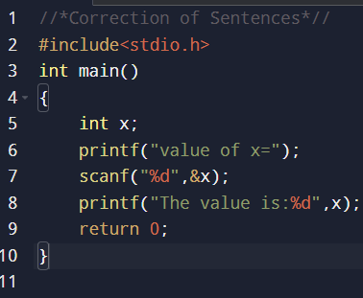

-THE END-

